Honda Parts Block: CLUTCH/FLYWHEEL (CVT)
Displayed for Honda Car: HR-V - Year: 2000 - Doors: 5 - Transmission: 5MT - Spec: 4WD
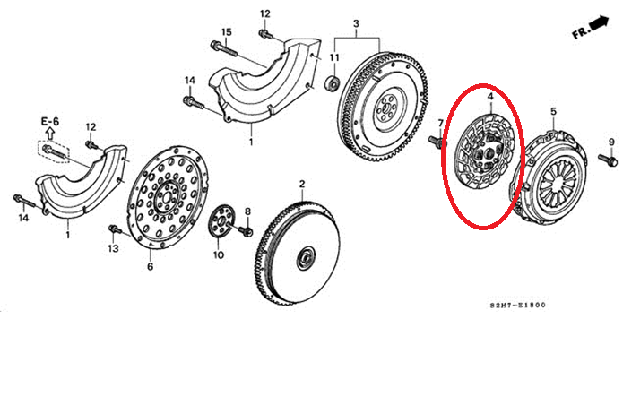
4 | PFKL415651 | DISK COMP., FRICTION

